Master Doc

Background

The journey to the 9th underworld
When you die your life flashes before your eyes, Imagine your whole life everything you have experienced, every moment you were apart of collapsing into one. What you are experiencing is the transcendence from the 3rd dimension to the 4th. The mind struggles because it can only comprehend the present; it lacks the ability to simultaneously grasp the present, past, and future. The mind overloaded with information tries to make sense of it all, it creates and contextualizes this into something you can understand. This is what you see when you are in the 4th dimension. A seemingly 3 dimensional space that feels lived in but with little to no people, alive with no life, a time-lapse that feels frozen in time. That is when you know you have reached, how it called by its inhabitants, The land of the dead.
Why are you here, What do you do. Everyones experiences in the land of the dead are unique to themselves, based on the lives you lived determines what you do. You may think it’s just to face the sins you committed in the land of the living, but it’s a little more complicated. You face the decisions you made, your failures, the successes, your regrets, and the disappointments. With only a vague idea of who our were in the land of the living your job is to make sense of your reality and humanity. You will see dead people from your life, or even who you have never met before, trying to figure out just like you how to get out of this place. You will also see the gods of this realm. The gods are the game makers watching over you, they create your trials. The game makers guide you into your trials showing you a way to your understanding of yourself.
In the land of the dead there is a Fungus. You can’t stay in this land forever your mind and body can’t handle it for too long. You only are your skeleton The longer you spend here the fungus starts to infect you. Spores attach to your bones growing into this long and stringy fungus that is reminiscent of muscle tissue. Once enough is attached the more and more involuntary movements start to take over yours. Because the fungus covers the last thing that make you human, your skeleton and especially your skull, the dead need a way to keep a sense of their individuality and humanity. Bandages try to cover the fungus, they they wear their clothes and even ribbons as a substitute for hair. But the thing that really tell you they have lost everything, the fungus is close to overtaking someone, is when they put on a luchador mask. The mask is the last attempt to take back your identity to reclaim who you were, but not long after is when they will loose full control over there body. You are reborn, like a zombie but the opposite you were dead but you’re now alive. The worst part about this fate is that you remain conscious unable to control your body. Left for eternity to torment others.

Themes
Identity and what make you human
• Liminal
• lonely
• longing
• nostalgic
• non-Euclidean
• non-linear
• Border story analogy
• Bario gangster
• Reality tv
• Tunnels
• Purity and Catholicism

Outline

The cards (the trials)
Plato’s Tripartite Soul Theory
The Rational ego
symbolizes the mind and represents the ruling class, a rational mind thinks, analyzes, and gauges options for the best outcome of any given situation. It denotes conscious awareness and works for the benefit of the entire soul, thus making it wise. The ruling class is always superior as they take optimum decisions for the welfare of society as a whole and rationally rule their kingdoms, hence they fall in this category.
The Spirited super ego
symbolizes the heart and represents the military class. Courage is the highest virtue of the spirit, and it’s associated with bravery, honor, and overcoming great challenges. Individuals who are ruled by the heart are hot-blooded like the soldiers who face adversities with great strength and overcome it with pride and honor to attain victory.
The Appetite id
symbolizes the stomach and represents the commoners, desire is ruled by sexual gratification, greed for money, comfort foods, and various other necessities that mostly take up an individual’s life. These individuals are just fulfilling their day-to-day obligations and not reaching out for a higher goal.
Id ego super ego

Wands - Frolic
Your child hood, what made you who you are why are you the way you are
A - What makes you feel good what make you feel bad
S - obedient following order not asking questions
R - Imagination - feeling and seeing things That your not ment to
Cups -Woe
Our desires, vices, booze, drugs that drown out the world around you
A - Alcoholism Substance abuse
S - The side affects of trauma,
R - Starvation
Gold - Malice
Greed power thee intent to feel better than someone else How did you. Distant in life, what did you do that wronged others, and why did you think that was acceptable.
A - Greed
S - Envy
R - Trolly experiment
Swords -Death
The end of ones life, this is were you face whether or not you felt fulfilled in life, if u succeeded or failed yourself
A - sexual abuse and purity
S - Murder
R - Suicide Selling your soul

Introduction (Ki) Spirit - Obedience Trauma Envy Murder Neglect people pleasing
The problem
Where am I, who am I, What is my goal?
The knowledge
This is Hell, I am Dead, I need to pay for my sins.
The resolution
Obey This worlds rules, do what needs to be done, Make a deal with The Game Maker, Follow the temptation Of the Animus.

Development (Sho) Rational Imagination Starvation Trolly Suicide

The problem

The knowledge
Inciting incident
The resolution
Rising action

Twist (ten) appetite Growing up Alcohol and drug Greed Sex and purity
The problem
Climax
The knowledge
The resolution
The wise old man appears and tell the story
“When i was 19 I so desperate for something better for me and my family, no Jobs could ever feed our family. I planted to jump the border, I had my best friend of al time with me, It was the hardest I hadn’t even in days we were at a pot where we needed to cross this big river,

Conclusion (Ketsu)
Falling action

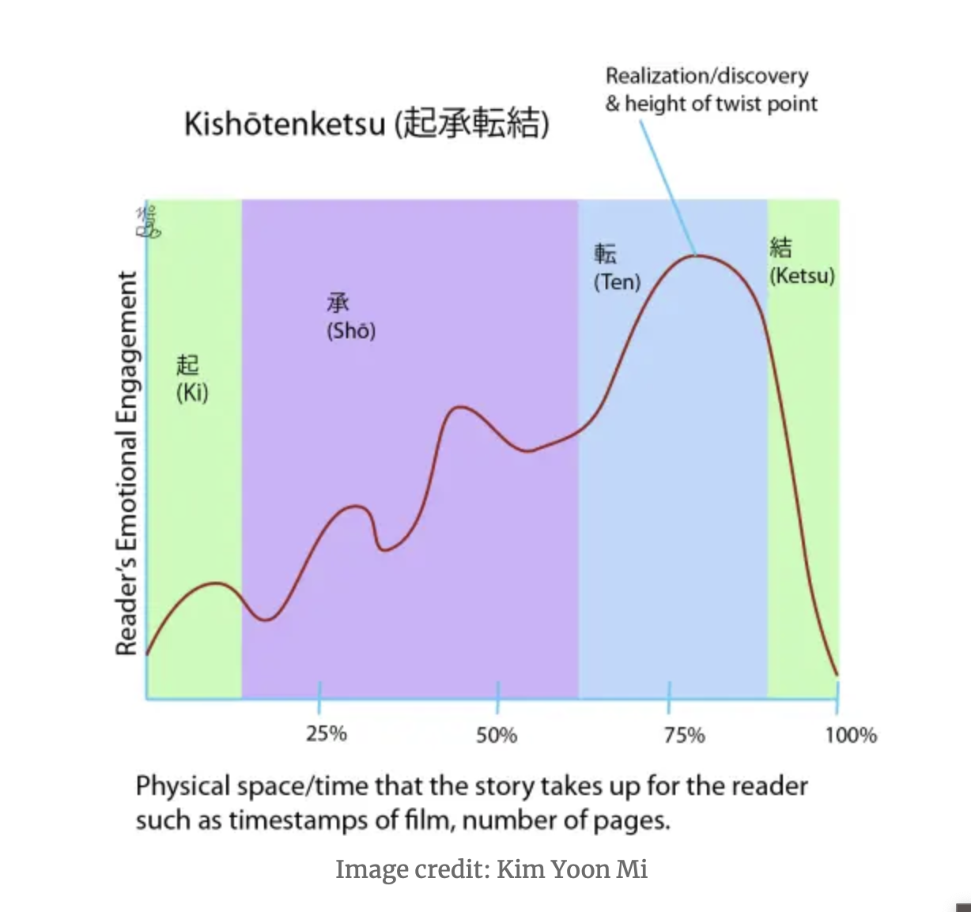
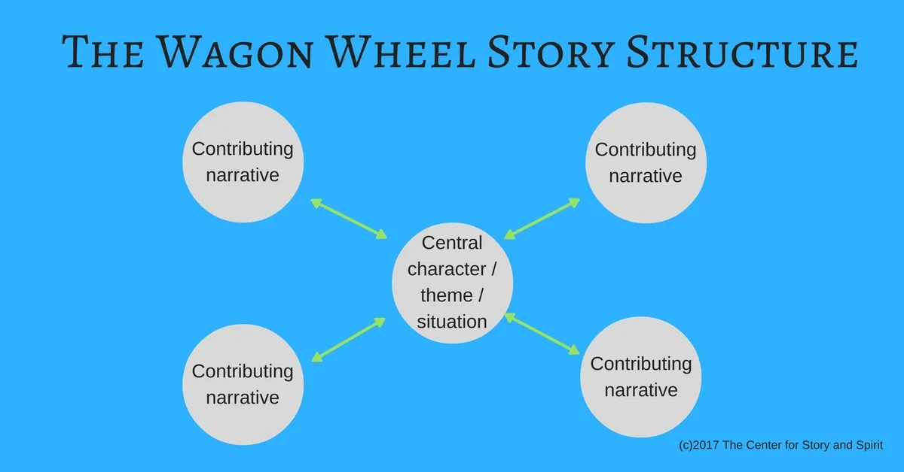

Characters

The Collective Unconscious
Anima: Symbolized by an idealized woman who compels man to engage in feminine behaviors
Animus: Woman's source of meaning and power that both creates animosity toward man but also increases self-knowledge
Hero: Starting with a humble birth, then overcoming evil and death
Persona: The mask we use to conceal our inner selves to the outside world
Self: The whole personality; the core of the total psyche
Shadow: The psyche's immoral and dark aspects
Trickster: The child seeking self-gratification, sometimes being cruel and unfeeling in the process
Wise old man: The self as a figure of wisdom or knowledge. For example, wizards and revered teachers frequently appear in the media and marketing messages to reflect this archetype.

The hero
- The Player
- Sol,

The persona

Anima
The feminine part of a man, The personality a man hides to fit into societal hierarchy. The woman who try to get the man to step into unknown territory, Eve getting Adam to eat the apple.

Animus
The masculine part of a woman.

The self

The shadow

The trickster
- the antagonist the boss type character
- The gamemnaker, the person pulling the strings, God, the universe in physical form. In this context This god is actually the “devil” who has killed the real “god” and perpetuates malice

Wise old man
-
- Most important This character will appear at the climax providing his wisdom and then vanishing.
- regular person who is on there own journey, they are not a god, a physic, all knowing being. They are no one, they re here just for a moment and right when they are needed.
- This person will see the hero at his lowest point where he will then tell a story that seems irrelevant but perfectly describe the situation the hero is facing.

Synopsis
You are the hero, You wake up on a corn wild and are taken to a dinner,

Part 1: Intro

Chapter 1: The Corn Field
You wake up in a corn field, looking at your hand you see a bare skeleton. without a moments notice a truck pulls right next to you and a figure (a god of some kind I don’t know witch one yet) throws you into the the trunk.
The gods are going to be the beings watching over the dead to make sure that they pass the trials they set up for the dead. They are the game makers curating the experience like a reality tv show.
The truck speeds through the corn field were the tital card appears in BIG TEXT.
The truck makes it on to road were it take takes you to your starting point. You don’t know why you are where you are you have a vague sense of who you were in the land of the living. The only thing you can be for sure of is the fact that you are here to pay for your sins.

Chapter 2: The Dinner
You’re dropped off at a dinner you get off out of the trunk and notice the person driving the car has disappeared. The car contains some items, keys, a note, and a flashlight.
You seem to be in in a fly over town frozen in time, It feels like people live in this world but are absent only left to be observed by yourself.
You step out of the truck surrounded by dozens of cars blocking you in not allowing you to go anywhere but the dinner. The only open door is the back door slightly ajar with a stream of light peaking through. Aside from what seems to be a playing card 11 Wands (Frolic Spirit, Super Ego) with the word obedience written on the card, being illuminated by the light there is nothing else to do than to step into the dinner.
The Card symbolizes Your first dilemma.
Do you Stop playing this curated game laid out for you, or do you obey and do what you are being forced to do. By stepping into the dinner You become obedient, you lose your free will and are agreeing to Follow the rules of this little game.
Entering what seems to be a small speakeasy, it is decorated as if there is a party happening. Tables adorned with flowers, half eaten food, cold and open cans of beer. Purses cellphones and other personal items dispersed around the room, but not a soul in sight. Following a light humming of the speakers onto the small stage you find a laptop illuminating the surrounding area. Interacting with the laptop Music starts to play, a very low slowed down beat glitching, skipping like a cd, and speeding up and slowing down erratically.
These noises cause someone to start banging on a gate leading to the rest of the dinner. Walking up to the person masked in darkness says.
“Hey You… Finally I’ve been waiting for so long. I can’t believe you guys call this a real restaurant. Im starving can you get over her so I can get some food. “
You clearly confused, try talking to this person but they just seem to ignore your questions. So Exploring backstage you find the key opening the gate. The person has gone and walked and sat himself at a booth waiting for you to get him his order.
As you get closer you notice This guy is wearing a luchador mask. And his bones have these black fibers slightly twitching as if this person is infected with a strange fungas. Waring overalls like an old farmer.
“Took you long enough, can I get my regular, actualy, can u add a little extra spice.”
“I don’t work here”
He stares at you with a blank stare for a little too long blinking periodically.
“Sorry I don’t know your order, I’ve never seen you or been here before, what is spice?”
“Oh your a funny one right. K’mon Hurry it up I don’t have all day.”
After pestering him 2 more time he finally gives and tells you what he wants. And you write it down on a note pad and give it to the kitchen which is clouded with darkness where a figure grabs the ticket and all you hear sizzling. As you wait you explore the dinner as someone appears at another booth. You take their order and send it of to the kitchen.
This starts the first game loop. You take peoples orders, send out their food and clean up when they are done. Where these people you are serving periodically tell you things or ask you questions. These interaction with give you clues on what you need to do next.
One guest says ‘ Your young arnt you, I haven’t seen bone so white since my cellular had buttons.”
“Why aren’t your bones white?” You say relieved someone might finally give you an answer to what is happening.
“Oh me, Ive just had to much spice”
“What is spice? How dose it not fall straight through you.”
“How are You moving”
“Um.. I just think and my body moves?”
‘How do you Think?”
“I don’t know I just can”
“Yeah that’s right its hollow up there, Your just a bundle of bones, look at you you don’t have any clothes on either. If I wanted to see your big bone I would have asked you to come to room 104.”
“Where is Room 104? ”
“Forget about it, you could at least have some common decency and put on your uniform.”
“This place has gone to shit,” he mumbles under his breath.
You pick up a few tables you find a uniform in the office and your last table someone with ought a mask on, they have almost fully consumed by the fungas, they seem to struggle staying still, twitching moving body twisting. All they get is a water and leavin a key to room 104. With a note that says “ I was like you once, get some rest you need it.”

Chapter 3: Room 104

Part 2: Dev

Part 3: Twist

Part 4: Conclusion

